Assignment 4
Topic: Different Sorting Algorithms

Name: Soham Ajit Puri
Roll. No: 04
Branch: CSDS_C1

Problem Statement: Sort products in a shopping cart based on price or ratings using different sorting algorithms and compare which is faster for large orders.

- Bubble Sort:

CODE:
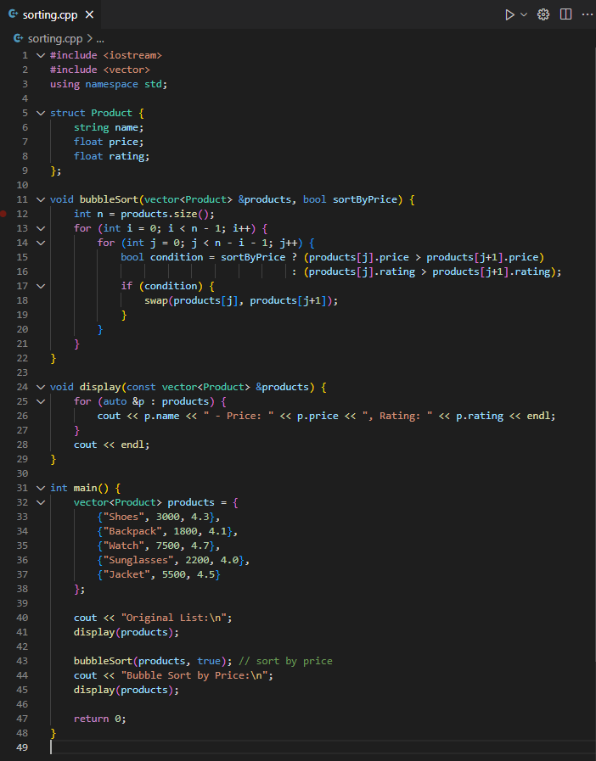
OUTPUT:

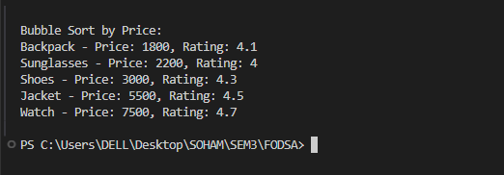
Step 1: Start
Step 2: Create structure Product.
Step 3: Input products.
Step 4: For i = 0 to n-2:
For j = 0 to n-i-2:
- Compare adjacent elements based on price/rating.
- Swap if out of order.
Step 5: Display sorted list
Step 6: Stop

- Selection Sort:

Step 1: Start
Step 2: Create a structure Product with name, price and rating.
Step 3: Input products into an array/vector.
Step 4: For i = 0 to n-2:
Set minIndex = i
For j = i+1 to n-1:
  - Compare based on price/rating
  - If smaller, update minIndex = j
Swap product at i with product at minIndex
Step 5: Display sorted list.

CODE:
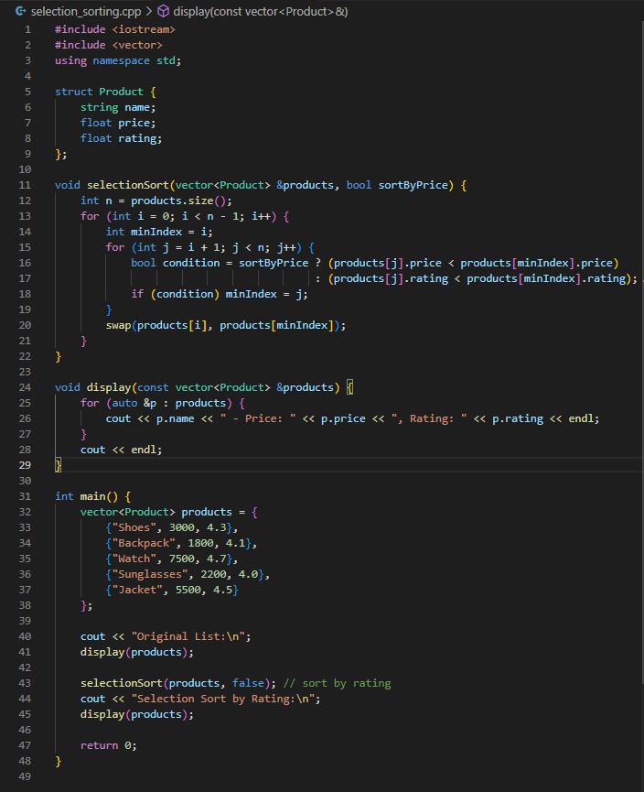
OUTPUT:
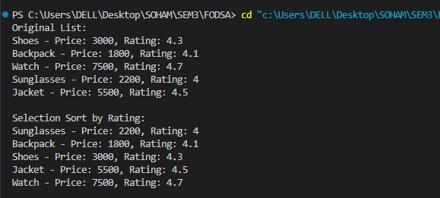
- Insertion Sort:

CODE:
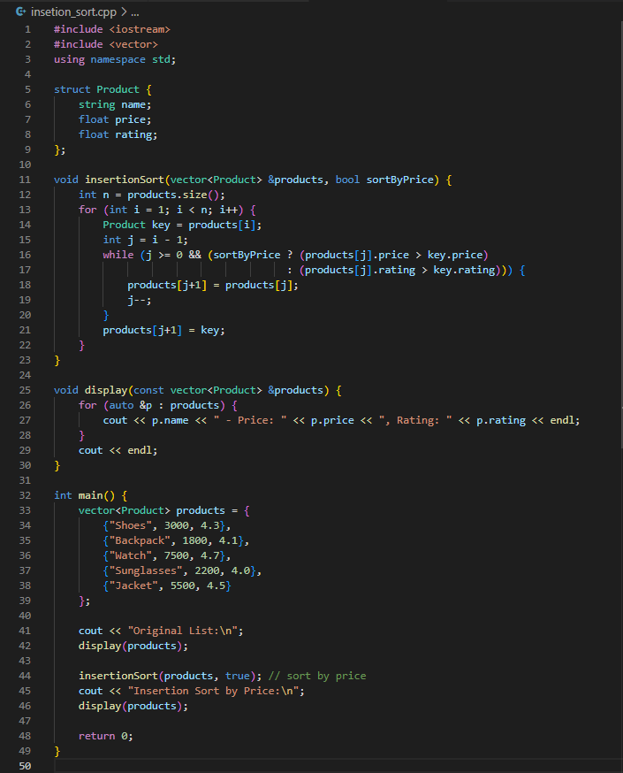
OUTPUT:
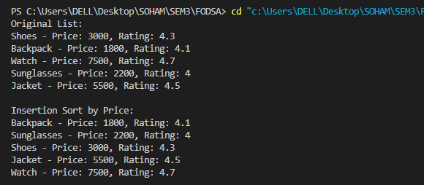
Step 1: Start
Step 2: Create structure Product.
Step 3: Input products.
Step 4: For i = 1 to n-1:
Store key = products[i]
Set j = i - 1
While j >= 0 and out of order:
  - Move products[j] to position j+1
  - Decrement j
Place key at position j+1
Step 5: Display sorted list.
Step 6: Stop

Conclusion:
The implementation of Bubble Sort, Selection Sort, and Insertion Sort shows that while all three can sort products based on price or rating, their efficiency varies with input size. Bubble Sort is the least efficient as it performs unnecessary passes, Selection Sort is more stable but still takes quadratic time in all cases, and Insertion Sort proves faster when the data is small or partially sorted. Overall, for larger shopping carts, Insertion Sort performs comparatively better among the three, though more advanced algorithms like Quick Sort or Merge Sort are preferable in real-world applications.

